EX. NO: 5
IMPLEMENTATION OF RAIL FENCE – ROW & COLUMN
TRANSFORMATION TECHNIQUE
Aim:
To write a C program to implement the rail fence transposition technique.
ALGORITHM:
STEP-1: Read the Plain text.
STEP-2: Arrange the plain text in row columnar matrix format.
STEP-3: Now read the keyword depending on the number of columns of the plain text.
STEP-4: Arrange the characters of the keyword in sorted order and the corresponding
columns of the plain text.
STEP-5: Read the characters row wise or column wise in the former order to get the
cipher text.
Program:
#include <stdio.h>
#include <string.h>
int main()
{
char text[100];
int i, len;
printf("Enter Plain Text: ");
scanf("%s", text);
len = strlen(text);
printf("Encrypted Text: ");
// First Rail
for(i = 0; i < len; i += 2)
printf("%c", text[i]);

// Second Rail
for(i = 1; i < len; i += 2)
printf("%c", text[i]);
return 0;
}
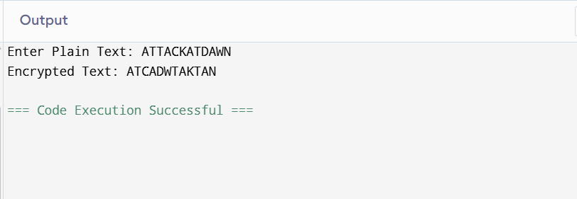
Result:
Thus the rail fence algorithm had been executed successfully.

